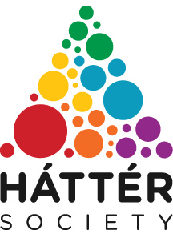
Háttér Society

Háttér Society, a Hungarian institution was founded in 1995. Currently, it is the largest and oldest lesbian, gay, bisexual, transgender, queer and intersex (LGBTQI) organisation in Hungary.

On the English website of the society Háttér (http://en.hatter.hu) the following mission statement is formulated: “Our aim is to draw the attention of professional and political public opinion, as well as the attention of wider society to the problems of LGBTQI people; the operation of services to assist them; getting to know the social situation and needs of LGBTQI people; mainstreaming these concerns in public services; protecting the rights of LGBTQI people and combating discrimination against them; increasing their well-being and health-consciousness; supporting LGBTQI-communities to organize themselves, preserve and promote their culture.”

Háttér is „fighting for a society in which no-one is discriminated because of their sexual orientation or gender identity, where all members of the LGBTQI community are free to live according to their identity, and receive the help they need to resolve the problems they might face.”

The society offers the followings:

- Information and counselling hotline (operators available via phone, Skype and chat)
- Personal counselling (10-12 counselling sessions for people struggling with self-acceptance, coming out, forming relationships, managing conflicts or stress or other mental health issues)
- Legal aid (free legal counselling and representation)
- HIV/AIDS program (0-24 HIV information hotline)
- Archive and library (LGBTQI-themed books, studies, films and news items)
- Advocacy (advocate for the elimination of discriminatory laws against LGBTQI people)
- Research (conduct research regularly to explore the social situation and problems faced by LGBTQI people)
- Training (regularly organize awareness raising trainings for members of the LGBTQI community; and sensitivity trainings for professionals working with LGBTQI people)
- Cultural and community events (lectures, movie screenings and discussions on the life, culture and history of LGBTQI people).

http://en.hatter.hu/
https://www.facebook.com/HatterTarsasag
hatter@hatter.hu
https://www.youtube.com/channel/UCeyEIw0IrrfVlizX-fixoCg

instagram.com/hattertarsasag

lelkisegely

